**Industrial Internship Report on**

**”BANK MANAGEMENT SYSTEM”**

**Prepared by**

**[ADITYA KUMAR]**

|  |
| --- |
| *Executive Summary* |
| This report provides details of the Industrial Internship provided by upskill Campus and The IoT Academy in collaboration with Industrial Partner UniConverge Technologies Pvt Ltd (UCT).  This internship was focused on a project/problem statement provided by UCT. We had to finish the project including the report in 6 weeks’ time  My project was on a bank management system where I created a full stack fully-functioning a bank management system that contains many different features such as login-generatorater and many more .  This internship gave me a very good opportunity to get exposure to Industrial problems and design/implement solutions for that. It was an overall great experience to have this internship |

**TABLE OF CONTENTS**

1 Preface 3

2 Introduction 4

2.1 About UniConverge Technologies Pvt Ltd 4

2.2 About upskill Campus 8

2.3 Objective 9

2.4 Reference 9

2.5 Glossary 10

3 Problem Statement 11

4 Existing and Proposed solution 12

5 Proposed Design/ Model 13

5.1 High Level Diagram (if applicable) 13

5.2 Low Level Diagram (if applicable) 13

5.3 Interfaces (if applicable) 13

6 Performance Test 14

6.1 Test Plan/ Test Cases 14

6.2 Test Procedure 14

6.3 Performance Outcome 14

7 My learnings 15

8 Future work scope 16

# Preface

Summary of the whole 6 weeks’ work.

About need of relevant Internship in career development.

Brief about Your project/problem statement.

Opportunity given by USC/UCT.

How Program was planned

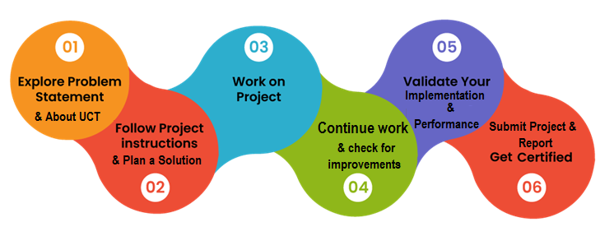

Your Learnings and overall experience.

Thank to all (with names), who have helped you directly or indirectly.

Your message to your juniors and peers.

# Introduction

## About UniConverge Technologies Pvt Ltd

A company established in 2013 and working in Digital Transformation domain and providing Industrial solutions with prime focus on sustainability and RoI.

For developing its products and solutions it is leveraging various**Cutting Edge Technologies e.g. Internet of Things (IoT), Cyber Security, Cloud computing (AWS, Azure), Machine Learning, Communication Technologies (4G/5G/LoRaWAN), Java Full Stack, Python, Front end**etc.

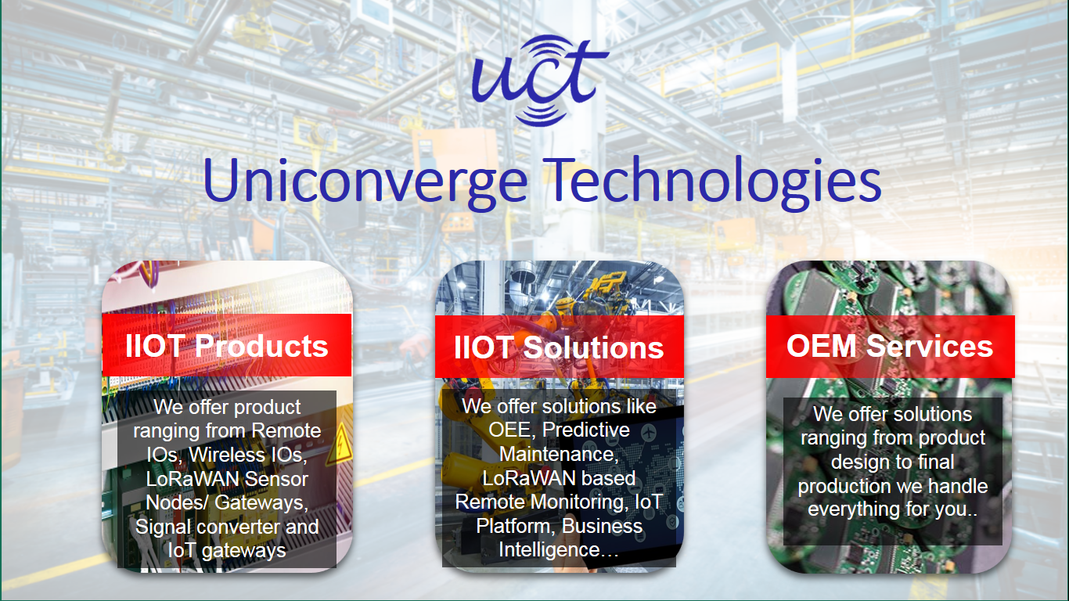

1. UCT IoT Platform **(****)**

**UCT Insight** is an IOT platform designed for quick deployment of IOT applications on the same time providing valuable “insight” for your process/business. It has been built in Java for backend and ReactJS for Front end. It has support for MySQL and various NoSql Databases.

* It enables device connectivity via industry standard IoT protocols - MQTT, CoAP, HTTP, Modbus TCP, OPC UA
* It supports both cloud and on-premises deployments.

It has features to  
• Build Your own dashboard  
• Analytics and Reporting  
• Alert and Notification  
• Integration with third party application(Power BI, SAP, ERP)  
• Rule Engine

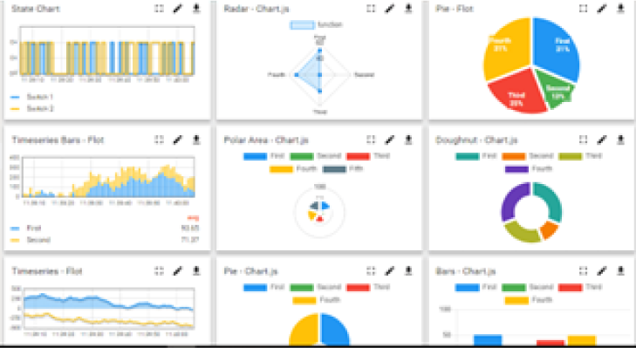 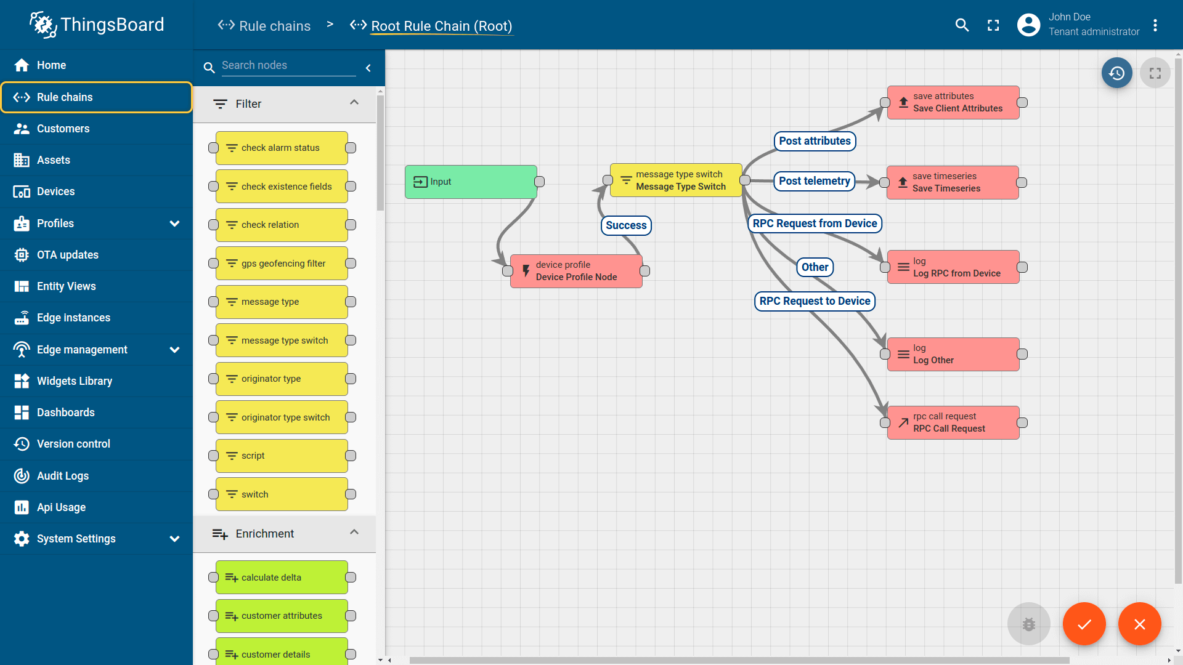

1. **Smart Factory Platform (****)**

Factory watch is a platform for smart factory needs.

It provides Users/ Factory

* with a scalable solution for their Production and asset monitoring
* OEE and predictive maintenance solution scaling up to digital twin for your assets.
* to unleased the true potential of the data that their machines are generating and helps to identify the KPIs and also improve them.
* A modular architecture that allows users to choose the service that they what to start and then can scale to more complex solutions as per their demands.

Its unique SaaS model helps users to save time, cost and money.

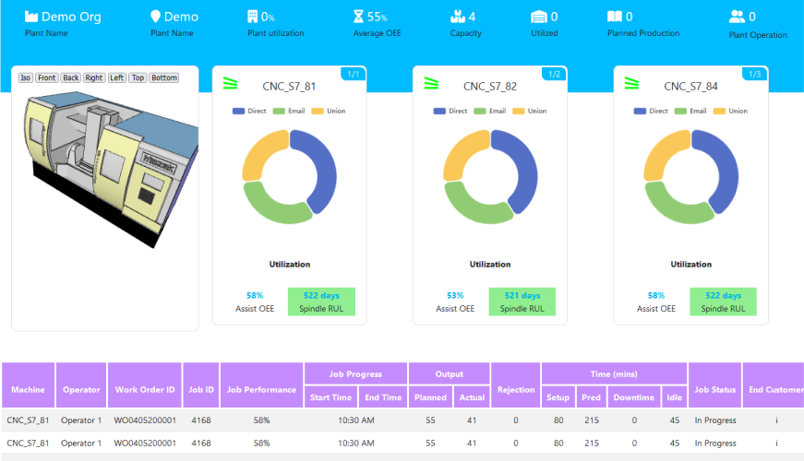 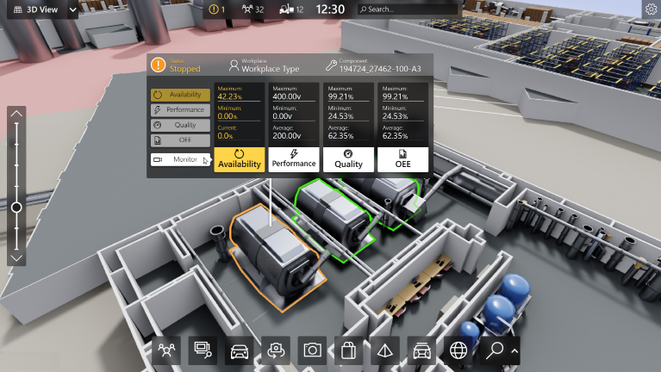

1. 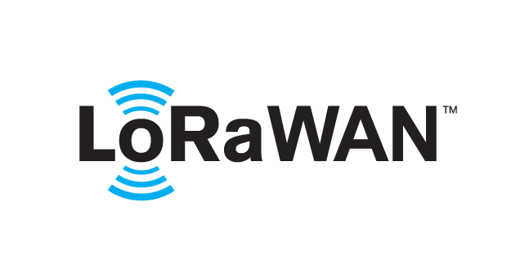 based Solution

UCT is one of the early adopters of LoRAWAN teschnology and providing solution in Agritech, Smart cities, Industrial Monitoring, Smart Street Light, Smart Water/ Gas/ Electricity metering solutions etc.

1. Predictive Maintenance

UCT is providing Industrial Machine health monitoring and Predictive maintenance solution leveraging Embedded system, Industrial IoT and Machine Learning Technologies by finding Remaining useful life time of various Machines used in production process.

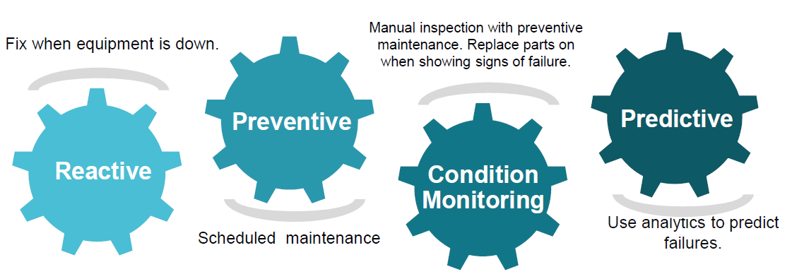

## About upskill Campus (USC)

upskill Campus along with The IoT Academy and in association with Uniconverge technologies has facilitated the smooth execution of the complete internship process.

USC is a career development platform that delivers **personalized executive coaching** in a more affordable, scalable and measurable way.



Seeing need of upskilling in self paced manner along-with additional support services e.g. Internship, projects, interaction with Industry experts, Career growth Services

<https://www.upskillcampus.com/>

upSkill Campus aiming to upskill 1 million learners in next 5 year

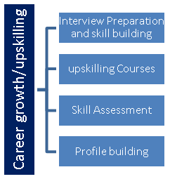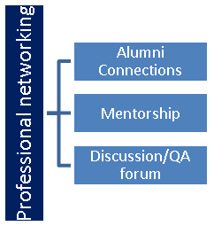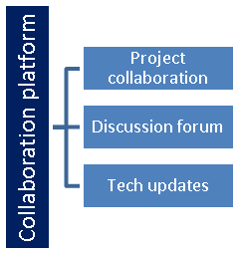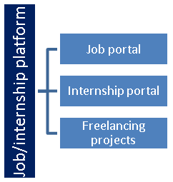

## The IoT Academy

The IoT academy is EdTech Division of UCT that is running long executive certification programs in collaboration with EICT Academy, IITK, IITR and IITG in multiple domains.

## Objectives of this Internship program

The objective for this internship program was to

 ☛ get practical experience of working in the industry.

 ☛ to solve real world problems.

 ☛ to have improved job prospects.

 ☛ to have Improved understanding of our field and its applications.

 ☛ to have Personal growth like better communication and problem solving.

## Reference

[1]Durga sir [Youtube chaneel]-Java{ https://www.youtube.com/playlist?list=PLd3UqWTnYXOmx_J1774ukG_rvrpyWczm0 }

[2] Tech Coder for sql workbench connection

[3]

## Glossary

|  |  |
| --- | --- |
| Terms | Acronym |
|  |  |
|  |  |
|  |  |
|  |  |
|  |  |

# Problem Statement

In the assigned problem statement []

[ Problem Statement:

A bank management system is designed to automate various banking operations such as account management, customer transactions, and employee management. The objective of this project is to create a robust and efficient system that simplifies the day-to-day operations of a bank. The system should be capable of handling a large number of customers and transactions while ensuring data integrity and security. ]

# Existing and Proposed solution

Solution:-

The bank management system is a comprehensive software application that integrates Java programming language and MySQL database. It provides a user-friendly interface for bank employees to perform various tasks efficiently. The key features and functionalities of the system include:

Customer Management:

Create and manage customer accounts, including personal information, account details, and transaction history.

Support functionalities like adding new customers, updating customer information, and closing accounts.

Account Management:

Enable customers to open various types of accounts such as savings, current, and fixed deposit accounts.

Handle account-related operations like deposits, withdrawals, transfers, and balance inquiries.

Calculate interest for different account types based on predefined rules.

Transaction Processing:

Facilitate secure and reliable transactions between accounts, ensuring proper validation and verification.

Implement transactional features such as fund transfers, bill payments, and account-to-account transfers.

Generate transaction receipts and update account balances in real-time.

Employee Management:

Maintain employee records, including personal information, roles, and responsibilities.

Implement authentication and authorization mechanisms to ensure secure access to the system.

Allow employees to perform specific tasks based on their assigned roles.

Reporting and Analytics:

Generate various reports, including daily transactions, customer account summaries, and employee performance.

Provide insights into key metrics like total deposits, withdrawals, interest earned, and customer growth.

Implement data visualization tools to present the information in a meaningful and intuitive manner.

Data Security and Integrity:

Encrypt sensitive data such as customer passwords and financial information to ensure confidentiality.

Implement backup and recovery mechanisms to prevent data loss in case of system failures.

Apply database normalization techniques to maintain data consistency and accuracy.

User Interface:

Design an intuitive and user-friendly interface for easy navigation and efficient use of the system.

Implement error handling and validation checks to prevent incorrect data entry and ensure data integrity.

Provide appropriate feedback and status updates to users during transaction processing.

By developing this bank management system, banks can streamline their operations, enhance customer service, and improve overall efficiency. It enables seamless management of customer accounts, secure transactions, and effective reporting and analytics, thereby facilitating better decision-making and customer satisfaction.

Things I made in this project :-

1.Login page created with cardno , and pin no, authentication (week 1)

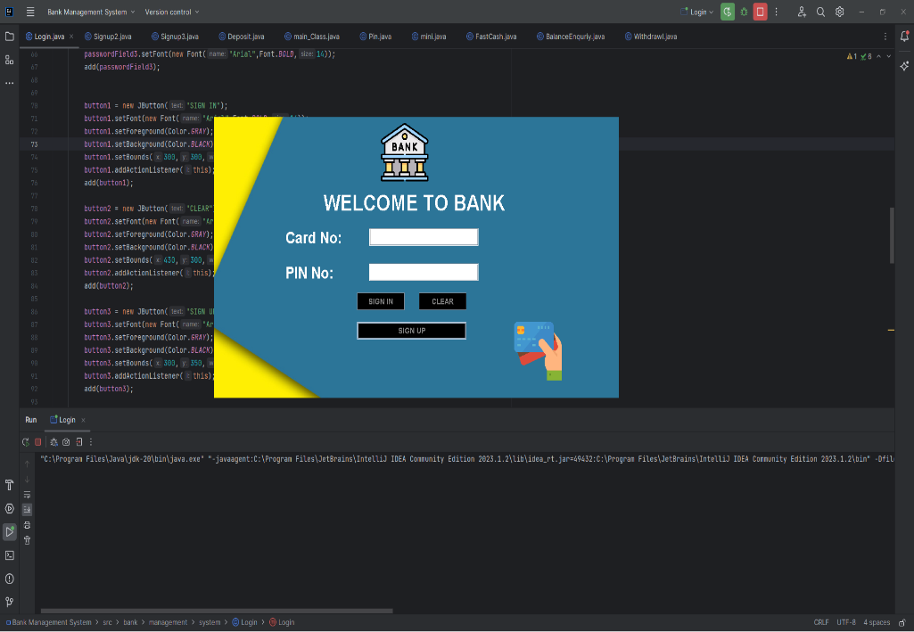

2. We can sign up if we have card no and pin no but if we donot have pin number then we can click omn signup and fill form to generate new crad no and pin number.

3. It is using mysql workbench to store the data .

4. It has functionality to have different application form number every time a new signup happens ,so the forms number are random and unique. 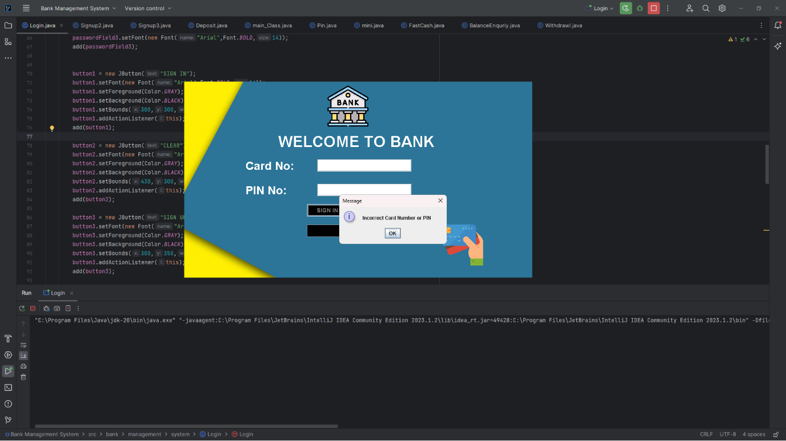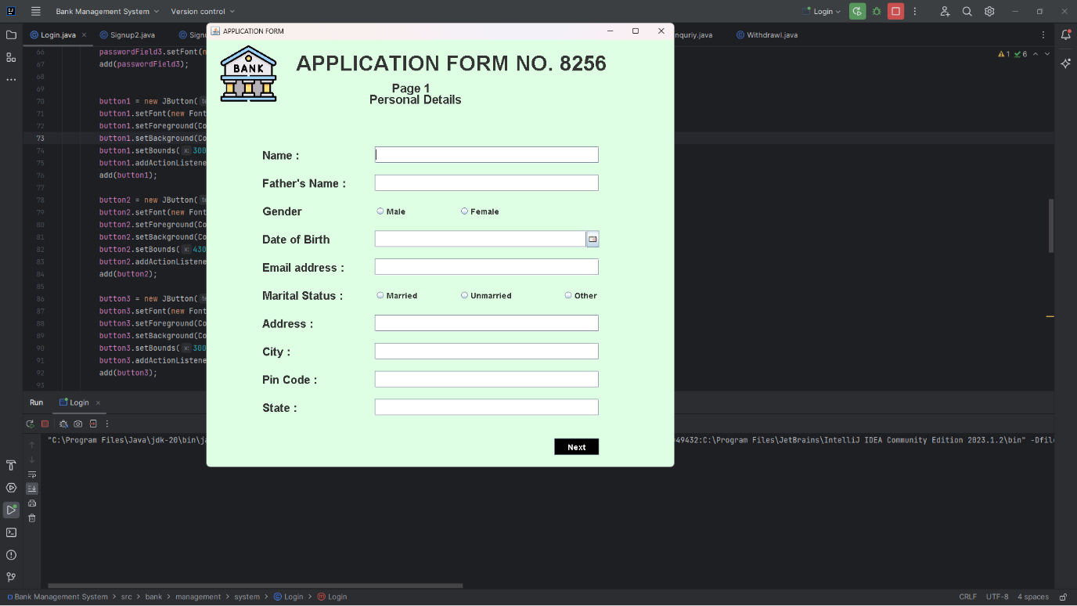

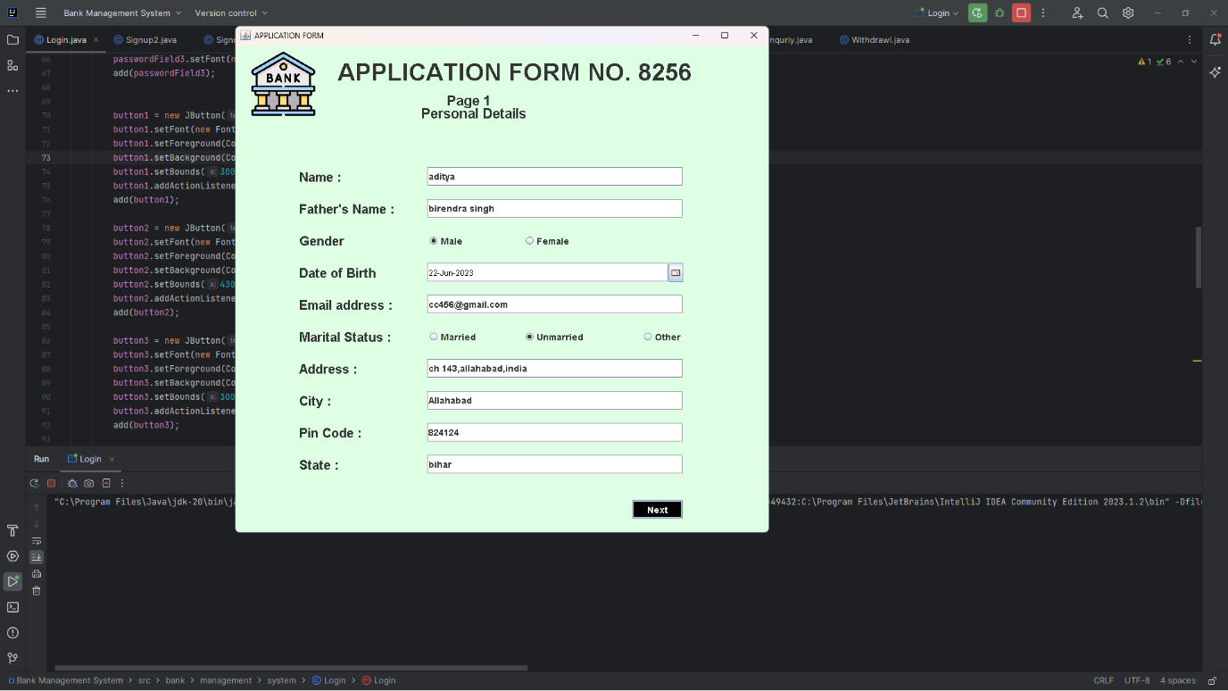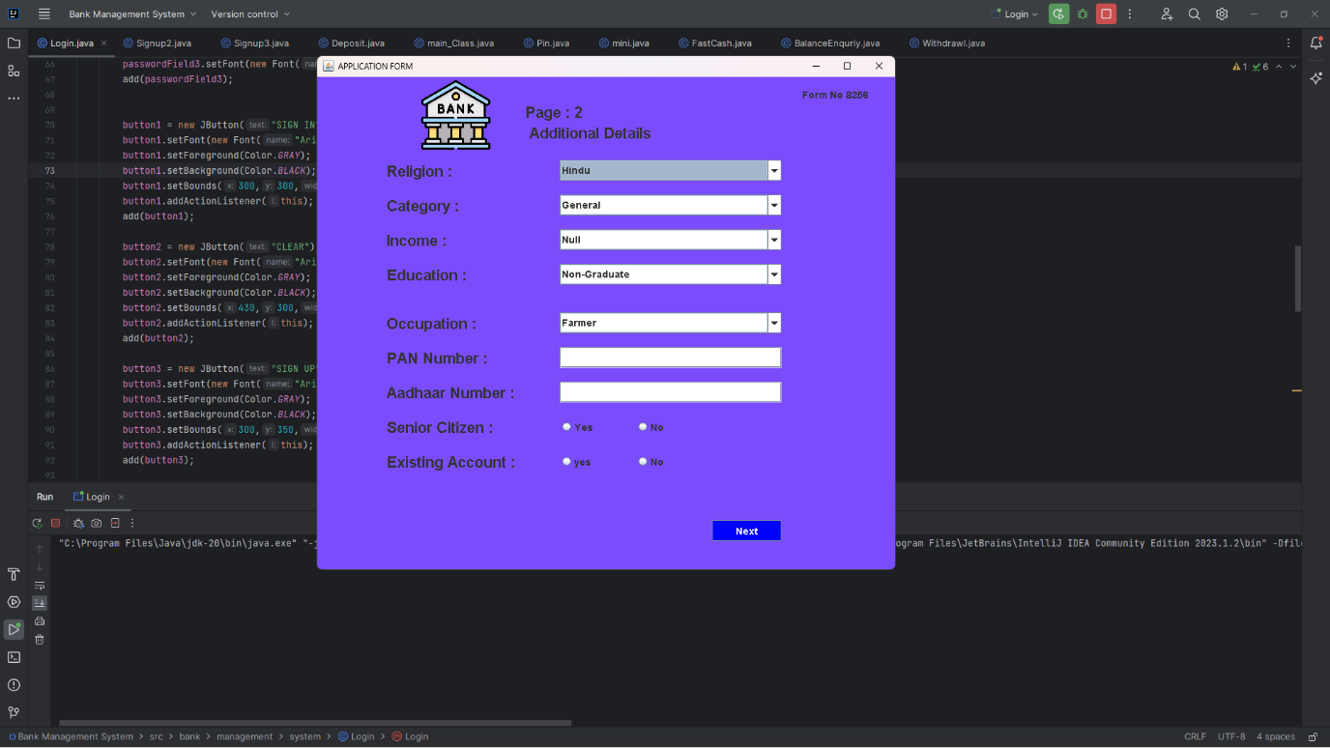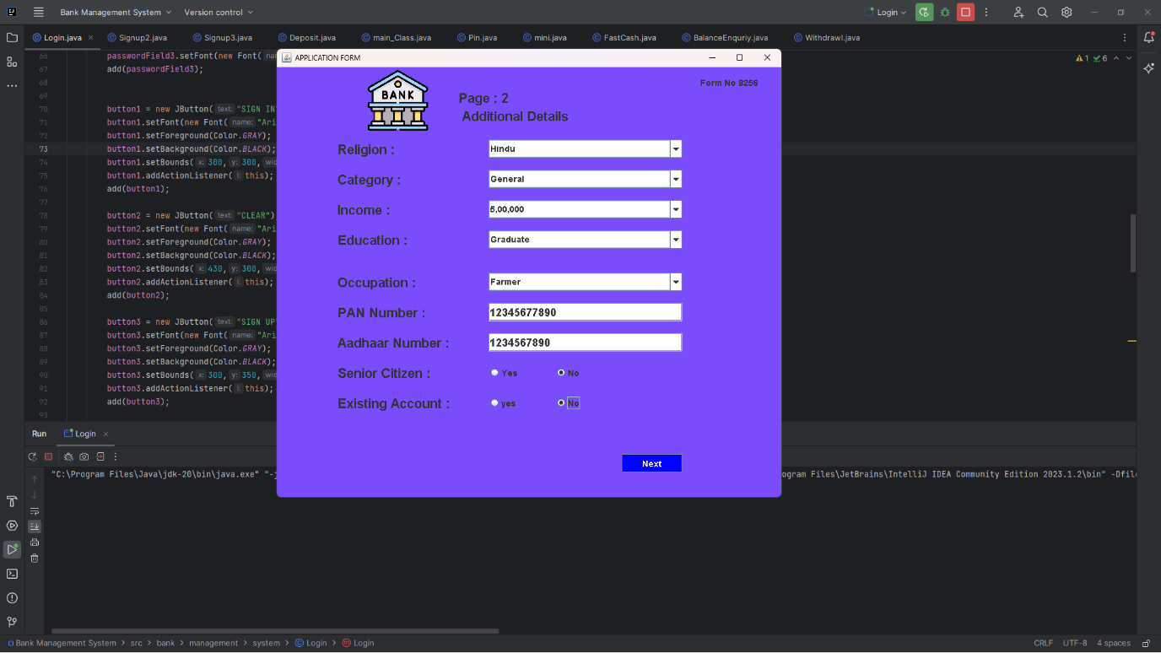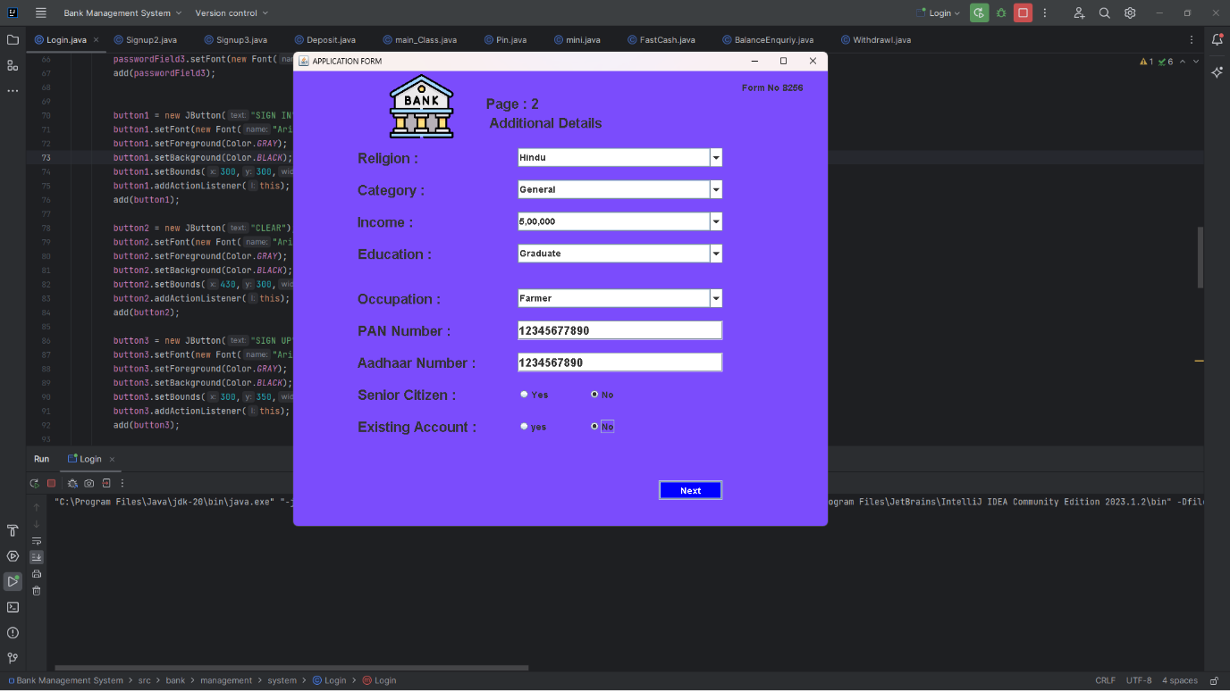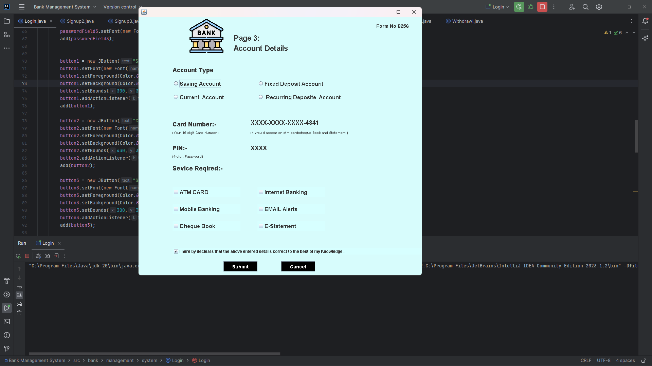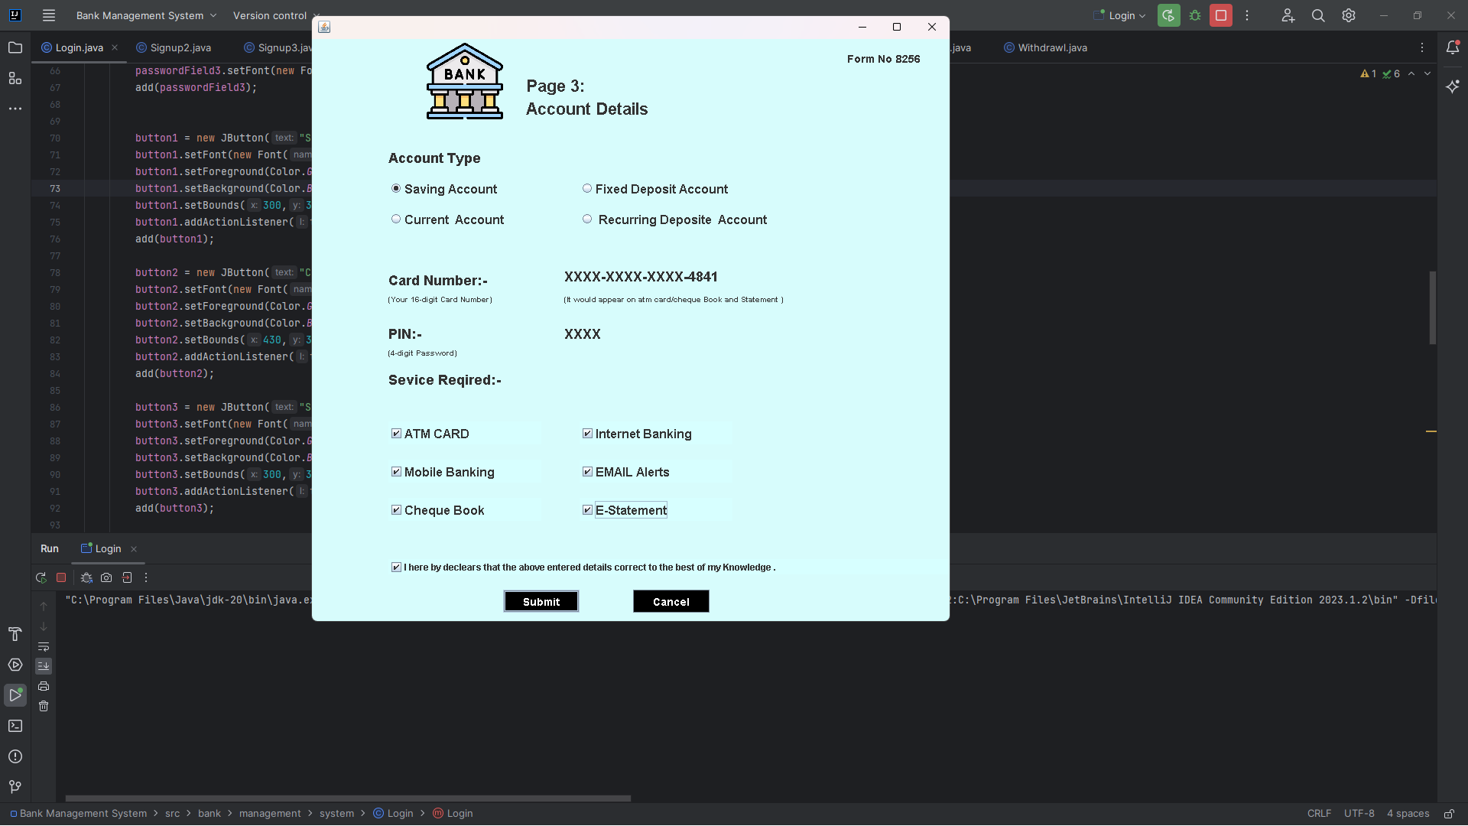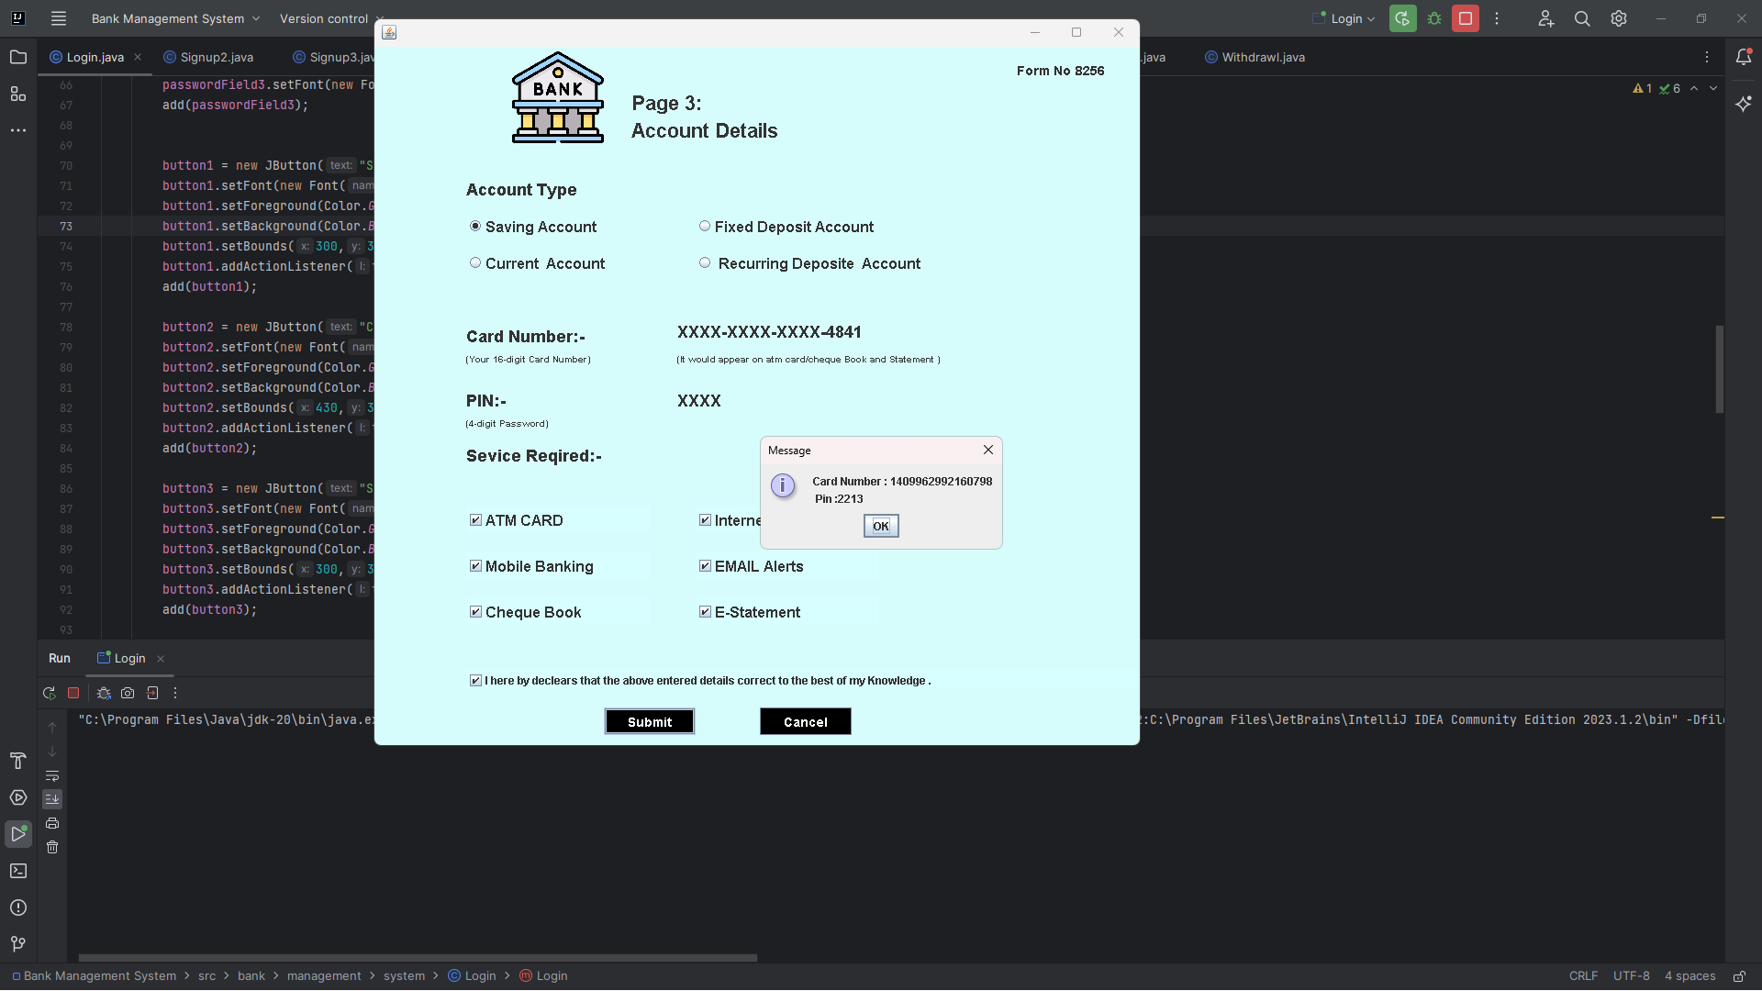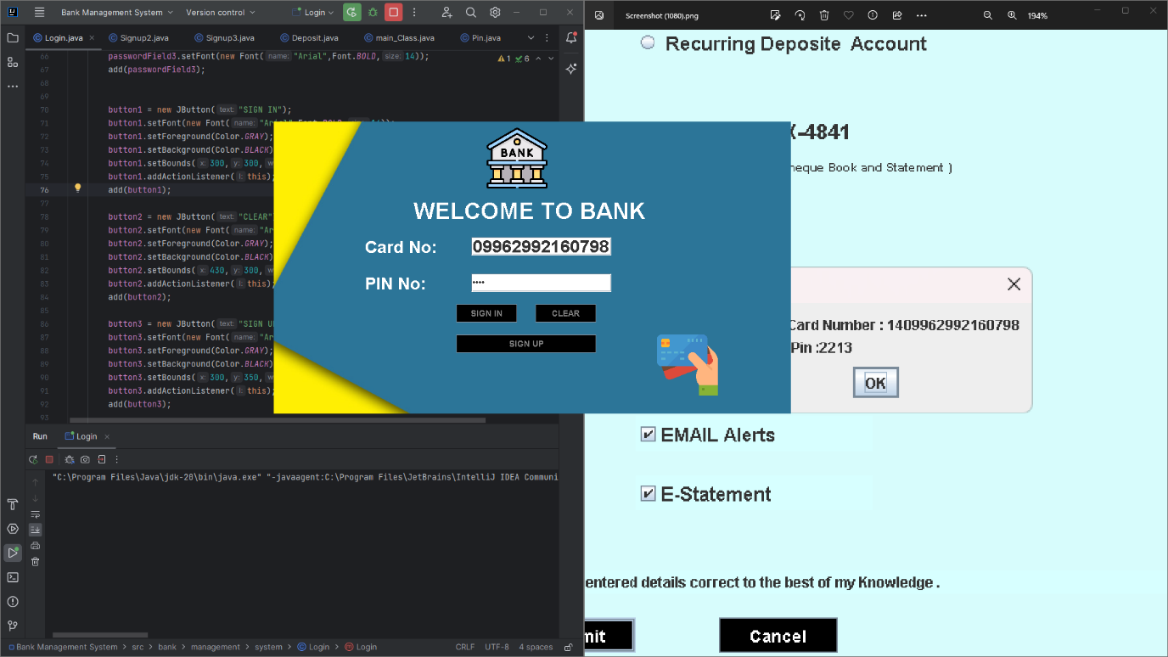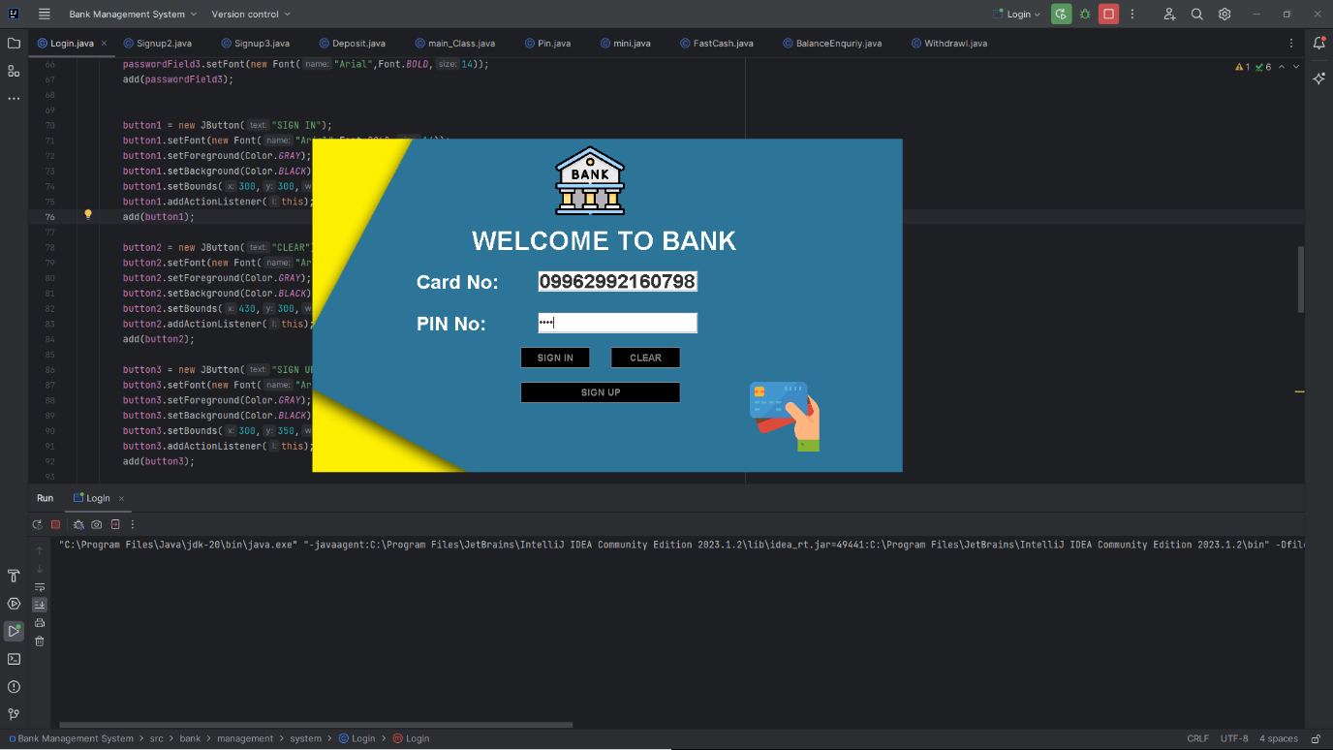

Till now this has been done after this new page with different button is going to come .

After getting the Card no and pin no we can enter into the Transection section which contains button.

Created four buttons which will perform task such as 1.Deposit,2.Cashdrawl,3.Fast Cash,4.Pin Change,5.Mini Statement , 6.Balance Enquiry, 7.Exit.

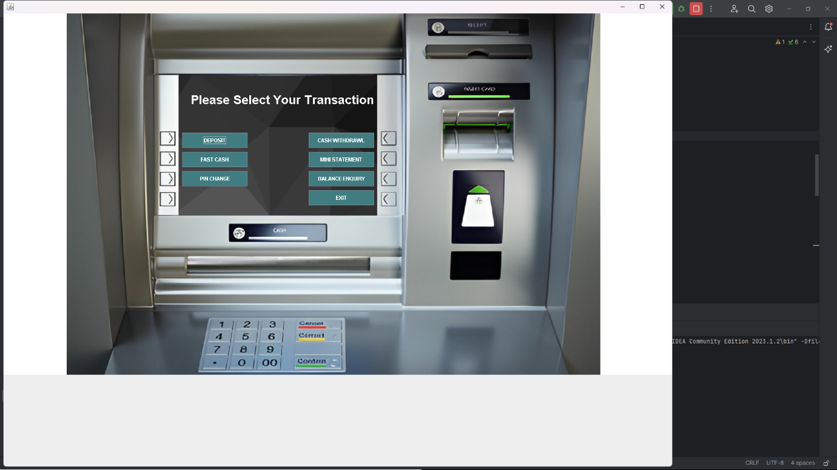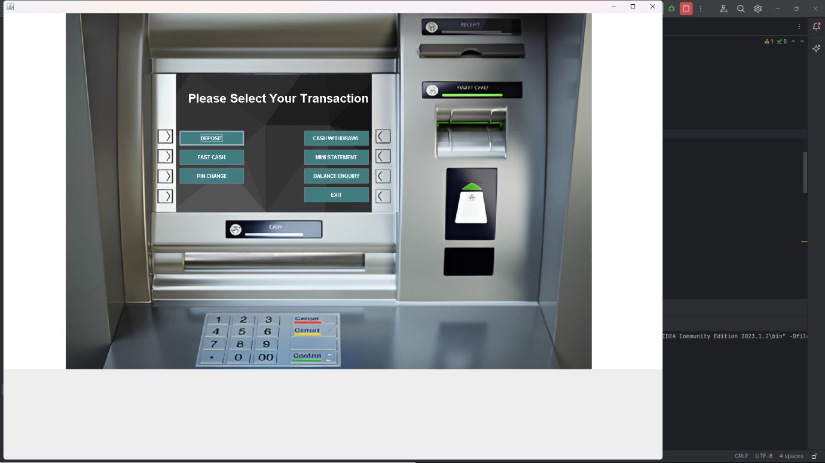

1. Deposit :- This section perform the function of depositing amount in your account.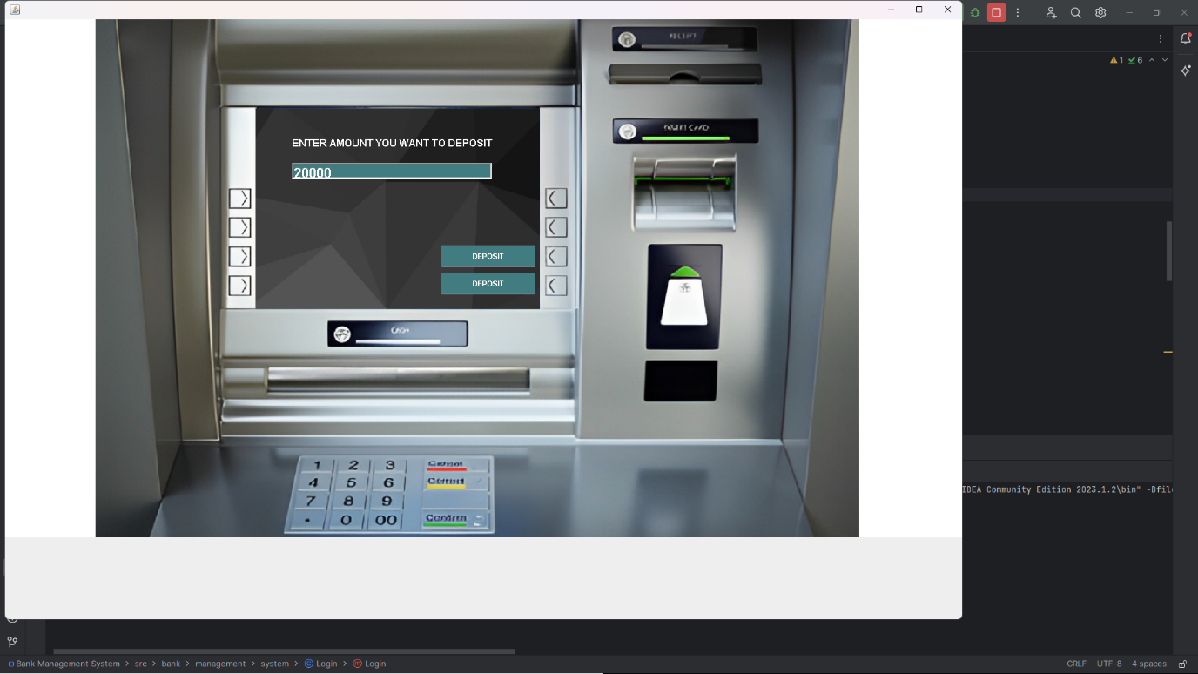

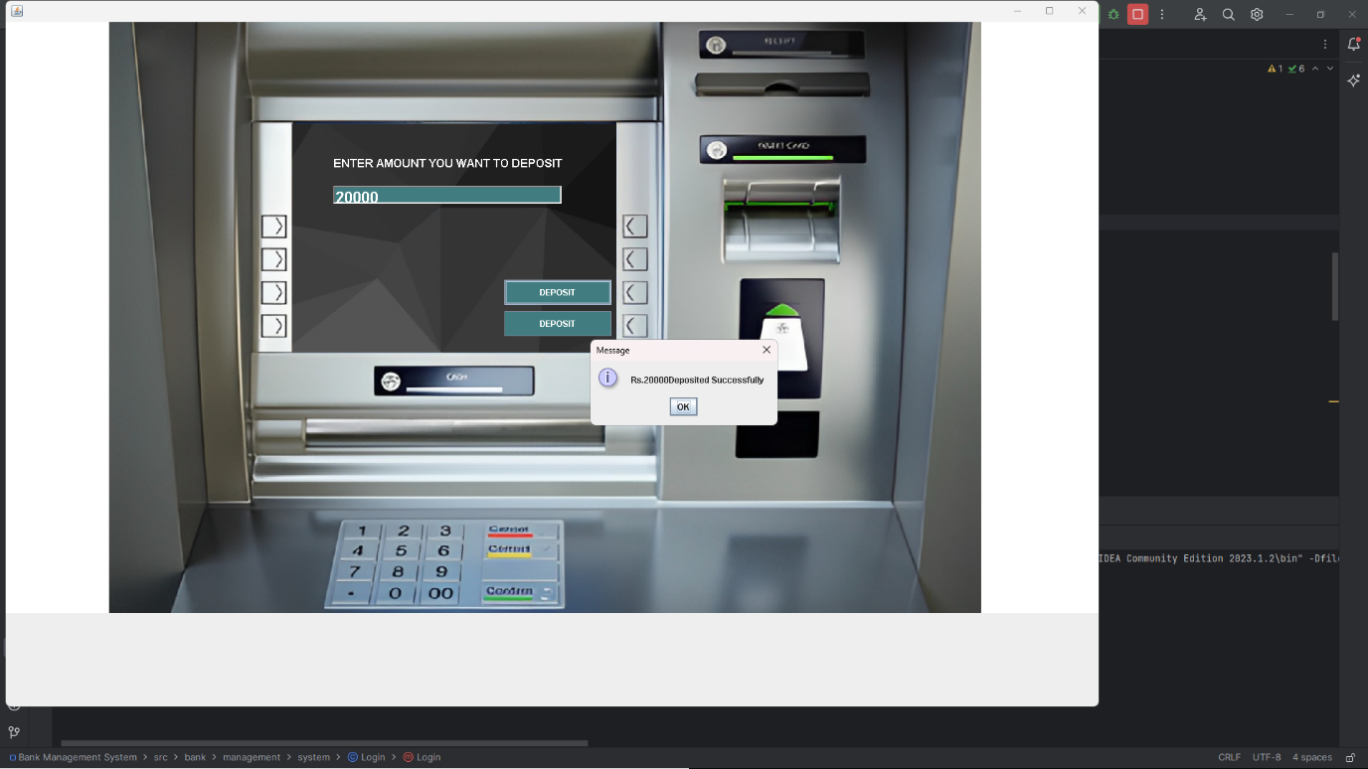

1. Cashdrawl:- This section performs the function of Withdrawal of cash from the account .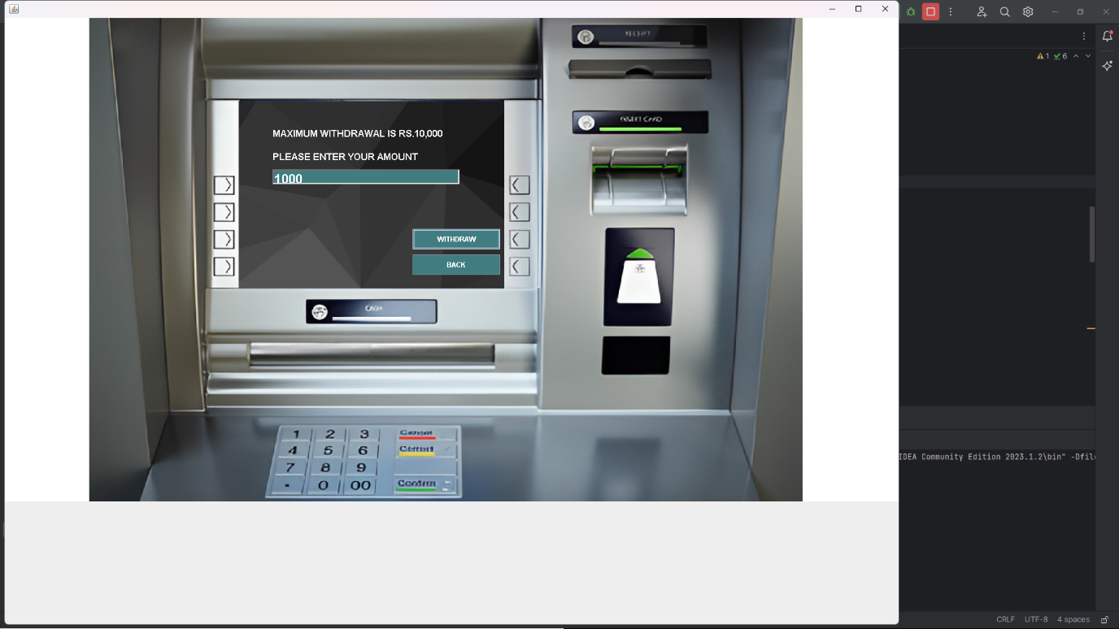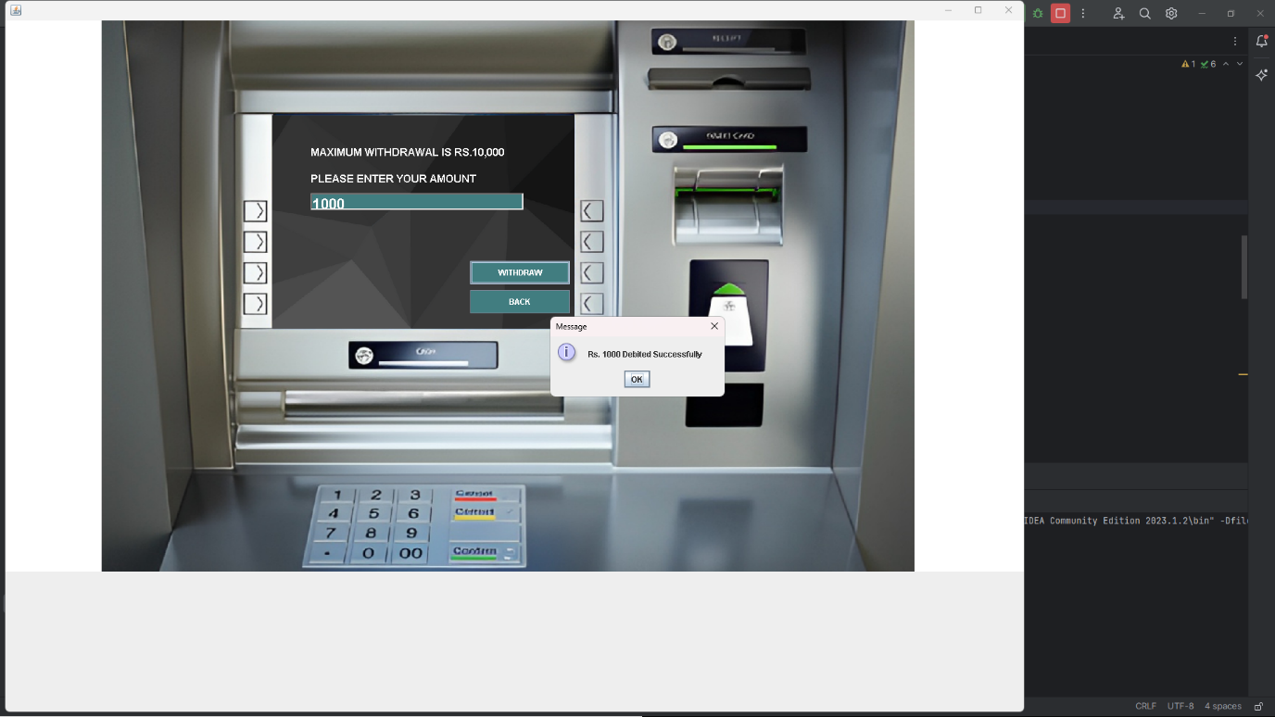
2. Fast Cash:- In this option we can withdraw amount with fast cash as in the form of 100,1000,500 etc.

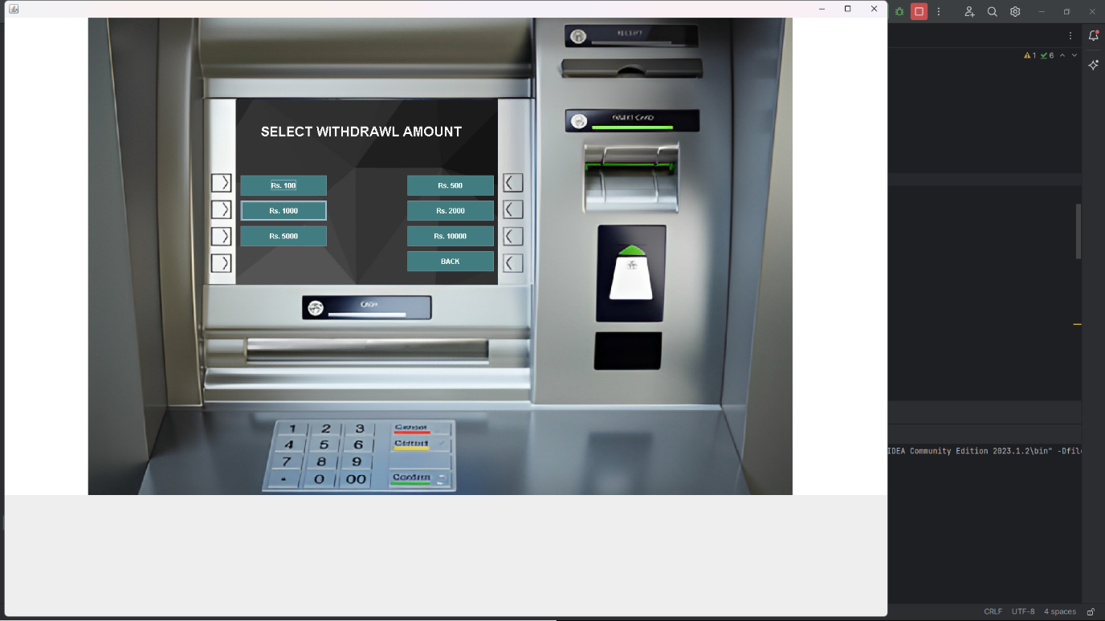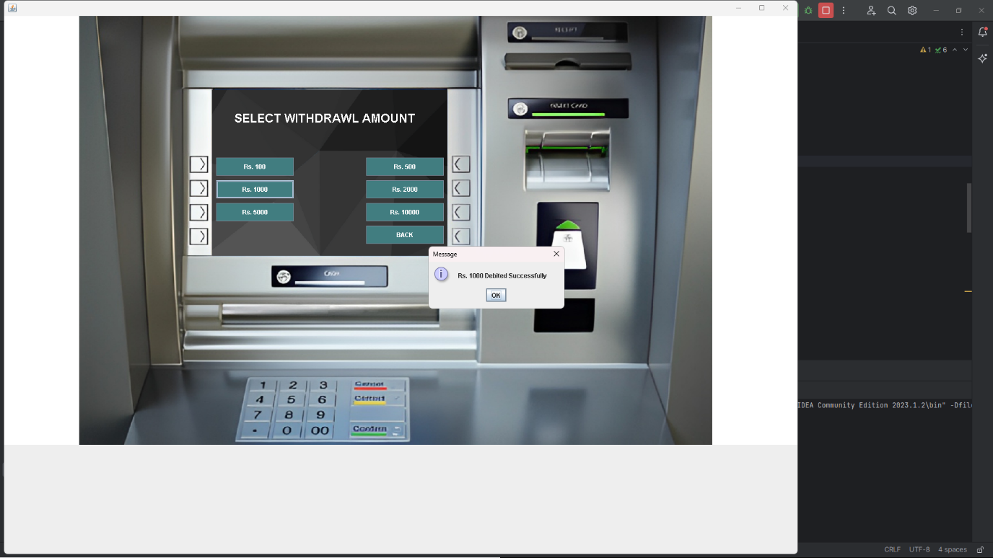

4 Pin Change:- In this option we get an advantage of changing pin number as we want .

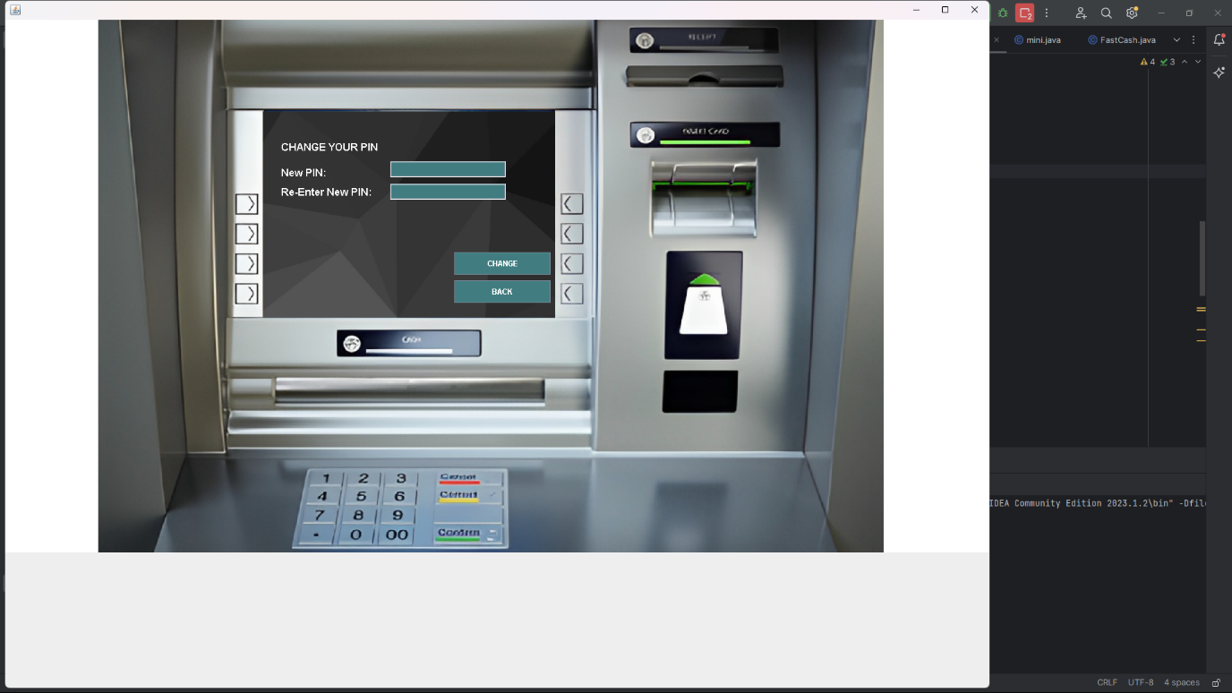

5 Mini Staetement:- This option contains the all information related to your transection.

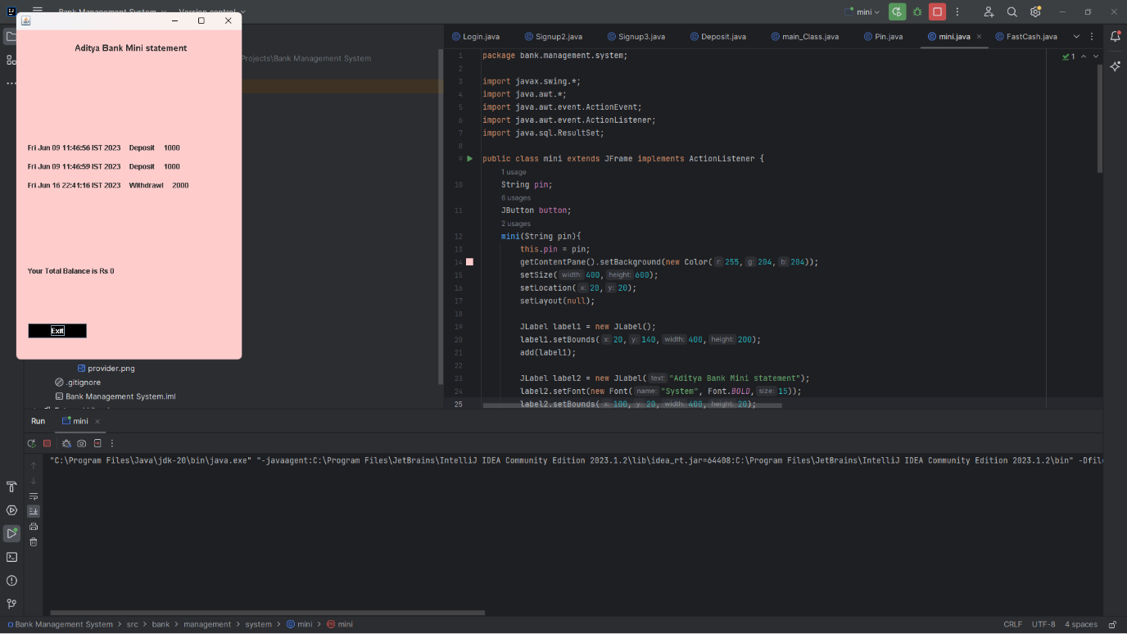

6. Balance Inquiry :- In this option we have a performance showing the balance related to the account .

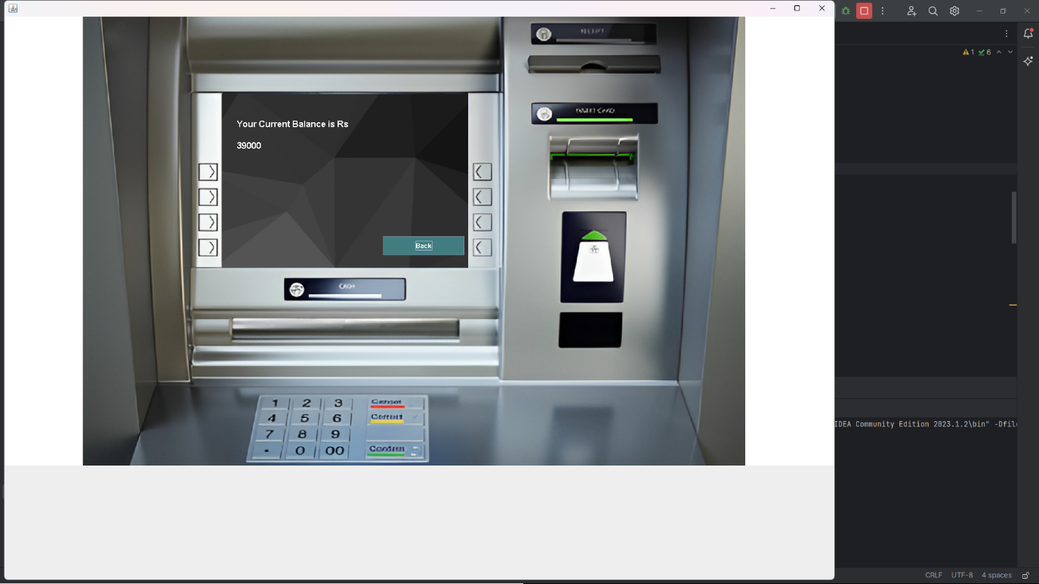

7. Exit :- It is used to exit the programme .

Now my whole project has been completed to add new features and any other details please contact me ;- at [aditymax7870@gmail.com](mailto:aditymax7870@gmail.com), +918853800609

## Code submission ( <https://github.com/Aditykumar6565/Bank-Management-System> )

## Report submission ( <https://github.com/Aditykumar6565/Bank-Management-System> ) : first make placeholder, copy the link.

# Proposed Design/ Model

Given more details about design flow of your solution. This is applicable for all domains. DS/ML Students can cover it after they have their algorithm implementation. There is always a start, intermediate stages and then final outcome.

## High Level Diagram (if applicable)

Figure 1: HIGH LEVEL DIAGRAM OF THE SYSTEM

## Low Level Diagram (if applicable)

## Interfaces (if applicable)

Update with Block Diagrams, Data flow, protocols, FLOW Charts, State Machines, Memory Buffer Management.

# Performance Test

This is very important part and defines why this work is meant of Real industries, instead of being just academic project.

Here we need to first find the constraints.

How those constraints were taken care in your design?

What were test results around those constraints?

Constraints can be e.g. memory, MIPS (speed, operations per second), accuracy, durability, power consumption etc.

In case you could not test them, but still you should mention how identified constraints can impact your design, and what are recommendations to handle them.

## Test Plan/ Test Cases

## Test Procedure

## Performance Outcome

# My learnings

You should provide summary of your overall learning and how it would help you in your career growth.

# Future work scope

You can put some ideas that you could not work due to time limitation but can be taken in future.